**Product Requirement Document**

1. **Goals**

The purpose of this project is to develop an all in one web application which provides different services to take complete care of dogs. A lot of dog lovers who wish to adopt a dog, spend a lot of time browsing through the internet and contacting dog shelters to adopt the right breed of dog which is documented. Many dog lovers give up on their wish of adopting a dog just because they don’t know where to adopt a dog. Dogs, just like human beings, have to get vaccinated and their medical history has to be recorded. A lot of people lose their dog’s medical records and have to search for it in a pile of papers which is time-consuming and it might also be lost. People are now looking into applications like Rover which provides services for dogs like dog walking, daycare, dog boarding, etc. Applications similar to rover are the solutions for people who want to own or who already own a dog during their busy schedule. Rover application provides services such as dog walking, daycare, dog boarding, home sitting, and drop-in visits.

There are other pet health care applications like Vitusvet which helps manage the pet’s health. However, there is no application that provides all the facilities that help you take care of your pet. Our solution/vision for the problem is to create an application that contains features such as dog walking, dog boarding, dog meetup, veterinary hospitals nearby, dogs available for adoption, and dog product businesses nearby. Our application will include all these features that make it unique from all the available web applications in the market and it would be a one-stop place for the dog owners to maintain their dogs.

1. **User Personas**

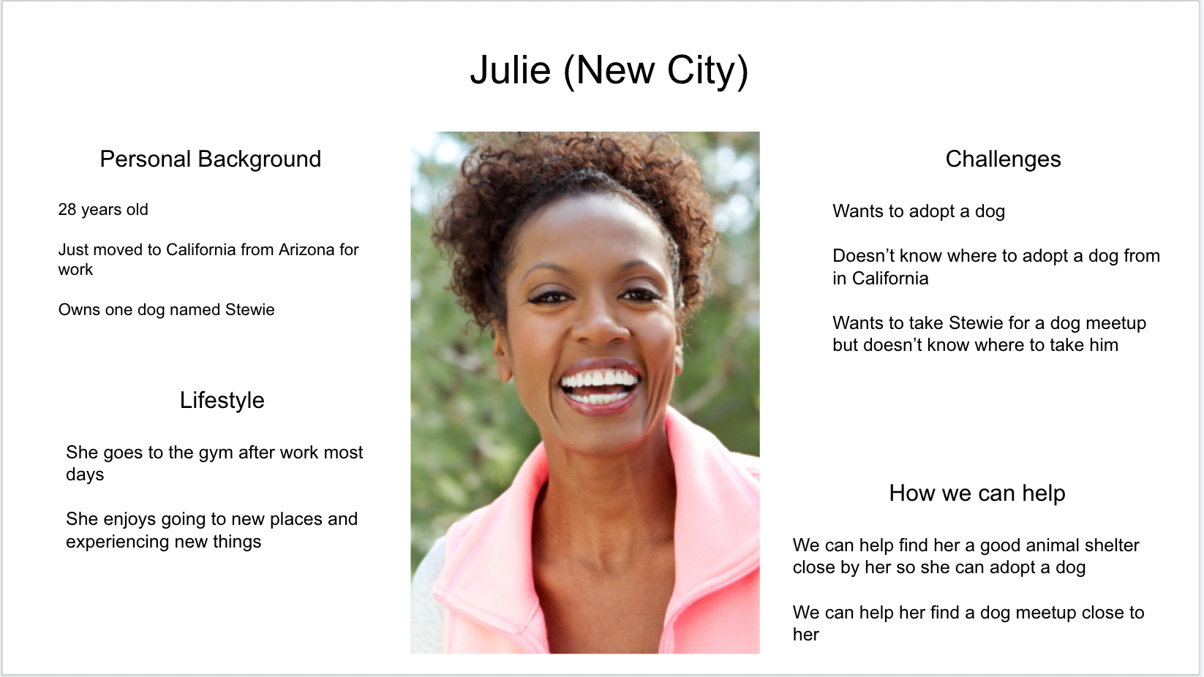

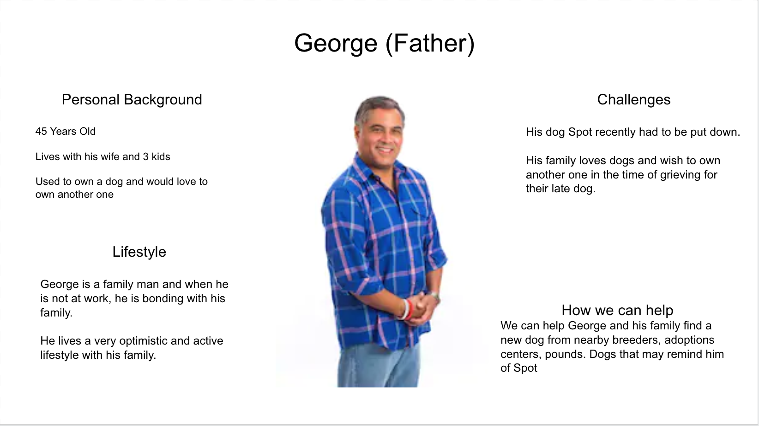

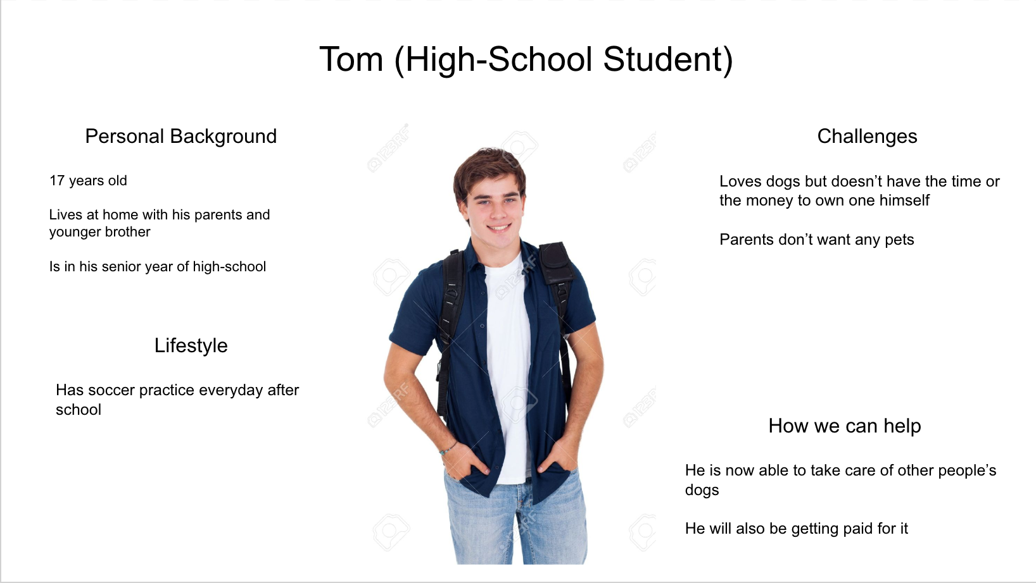

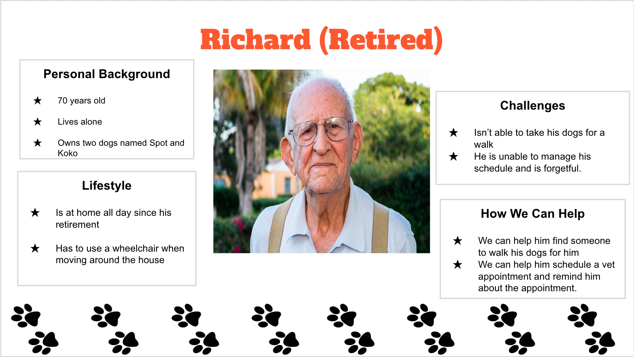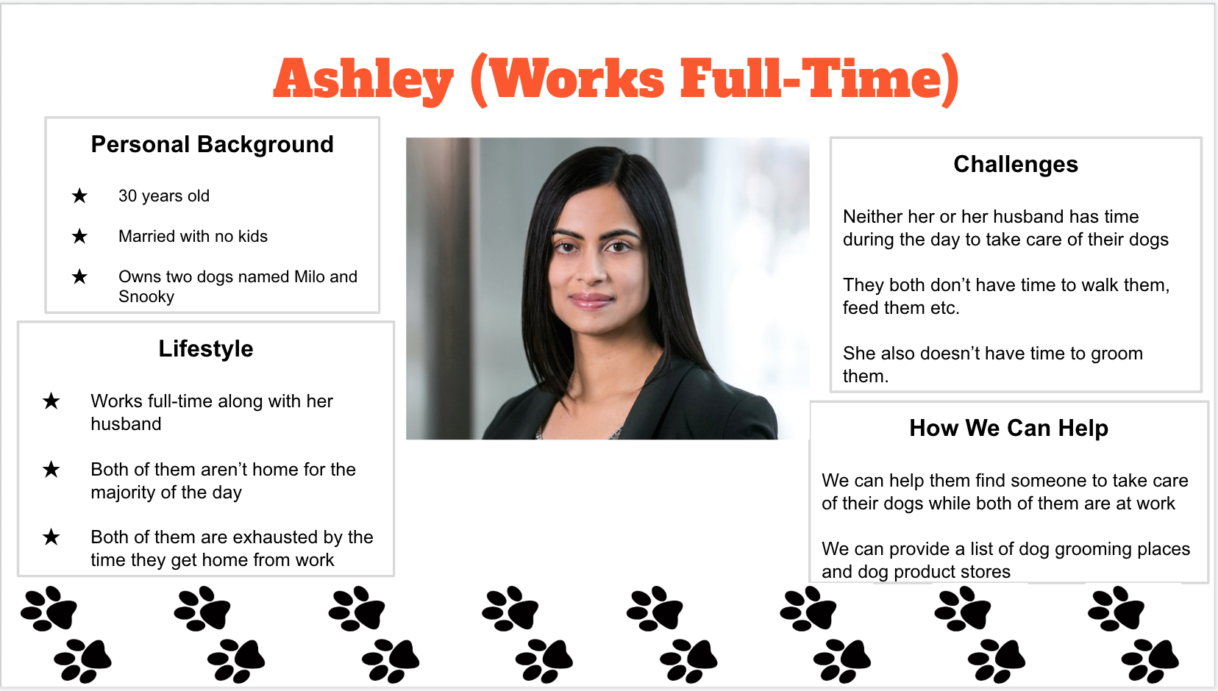

1. **User Stories**
   * As a first time user, I want to create an account so that I can use the web application.
   * As a user, I want to login to my profile so that I can access my account.
   * As a first time user, I want to create my profile so that I have my details saved for accessing different features of the web application.
   * As a user, I want to edit my profile if there are any changes to my personal information.
   * As a user, I want to create a profile for my dogs to save their information.
   * As a user, I want to look at different services offered in the web application on the home screen after I log in so that I can choose the service I want for my dog.
   * As a user, I want to be able to choose the Dog Walking service so that I can let my dog be walked by a dog walker.
     1. As a user, when I select dog walking service, I would like to see a list of dog walkers in my area along with the price they charge per hour and the reviews/ratings of the dog walkers by the users to get confidence on the dog walker with whom I will send my dog for dog walking.
     2. As a user, I would like to message the dog walker about the time when I want my dog to be walked.
   * As a user, I would want to be able to choose to adopt a dog service to choose a dog I want to adopt.
     1. As a user, I would want to search for a specific breed of dogs that I am looking to adopt.
     2. As a user, I would like to get alerts for specific breeds that I am interested in adopting when they are posted for adoption.
     3. As a user, I would like to look at the price of adopting a dog.
     4. As a user, I would like to look at the location when the dog is available for adoption.
     5. As a user, I would like to send a message to the person who put up the post for adoption about more details.
   * As a user, I would want to be able to choose schedule vet appointments service to schedule a vet appointment for my dog.
     1. As a user, I would like to look at the vets nearby for easier commute.
     2. As a user, I would like to look at the available appointments in the vet I choose to go to.
     3. As a user, I would like to look at the reviews of the vets for better confidence in the vet I am choosing to go to.
     4. As a user, I would like to book an appointment for the vet.
   * As a user, I would like to be able to choose a dog boarding service so that I can leave my dog there when I travel.
     1. As a user, I would like to look at nearby dog boarding facilities, people who are willing to take care of my dogs, and dog kennels.
     2. As a user, I would like to look at the rating of the dog boarding facilities, people who are willing to take care of my dogs, and dog kennels.
     3. As a user, I would like to message the dog boarding service providers about more information.
     4. As a user, I would like to look at cost per day for dog boarding.
   * As a user, I would like to be able to choose to find nearby dog services.
     1. As a user, I would like to look for dog supplies stores near me.
     2. As a user, I would like to look for dog grooming services near me.
   * As a user, I would like to be able to view all available dog meetups near me
     1. As a user, I would like to create my own dog meetup and give other people the opportunity to come to mine.
   * As a user, I would like to be able to upload my pet’s medical documents.
   * As a user, I would like to be able to log out of the web application.

1. **Server Sitemap**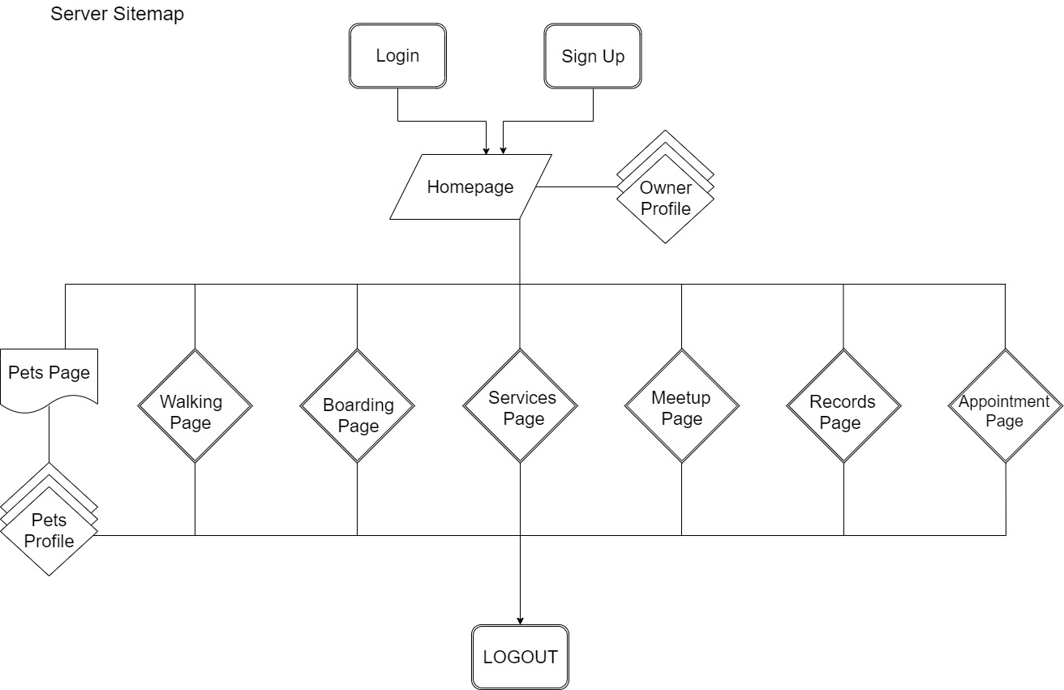
   * Homepage
     1. Create your own profile screen
     2. Edit your own profile screen
   * Your Pets Page
     1. Create your pet profile screen
     2. Edit your pet profile screen
   * Dog Walking Page
   * Dog Boarding Page
   * Dog Services Page
   * Dog Meetup Page
   * Dog Records Page
   * Vet Appointment Page

Users after logging in sees/ logs on the home page and then their pets page which would eventually lead them to any desired feature page. No particular map to reach to feature pages and finally, the user can exit the application (the logout page).

1. **Page Descriptions**

|  |  |
| --- | --- |
| **Page** | **Elements** |
| Homepage | Your profile:   * Name * Age * Photo * Number of pets Etc   List of all available services  News Feed of services near you |
| Your Pets Page | List of all your pet profiles  Pet profile:   * Name * Age * Photo * Breed Etc |
| Dog Walking Page | List of dog walkers near you  List of dogs that need to be walked near you |
| Dog Boarding Page | List of nearby dog boarding places  List of dogs that need to be looked after |
| Dog Services Page | List of dog product stores  List of dog grooming places  Dog adoption filters  Dog adoption list  Schedule Vet appointments button |
| Dog Meetup Page | Create a meetup button  Dog meetup list |
| Dog Records Page | List of all the different paperwork for your dogs |
| Vet appointment Page | List vets nearby |

1. **Wireframes**

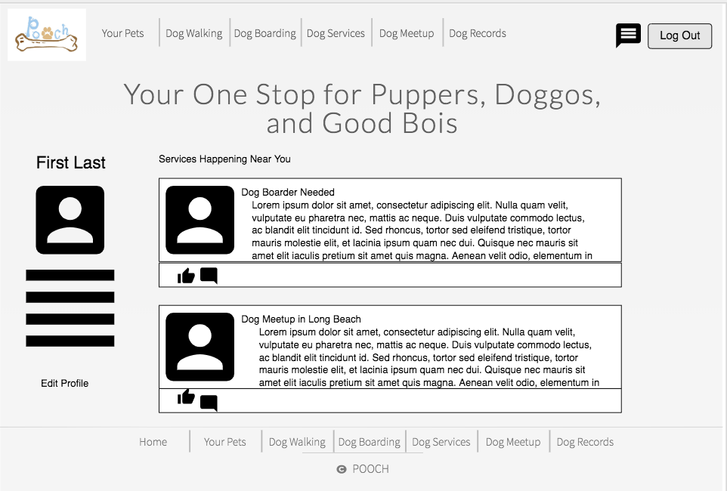

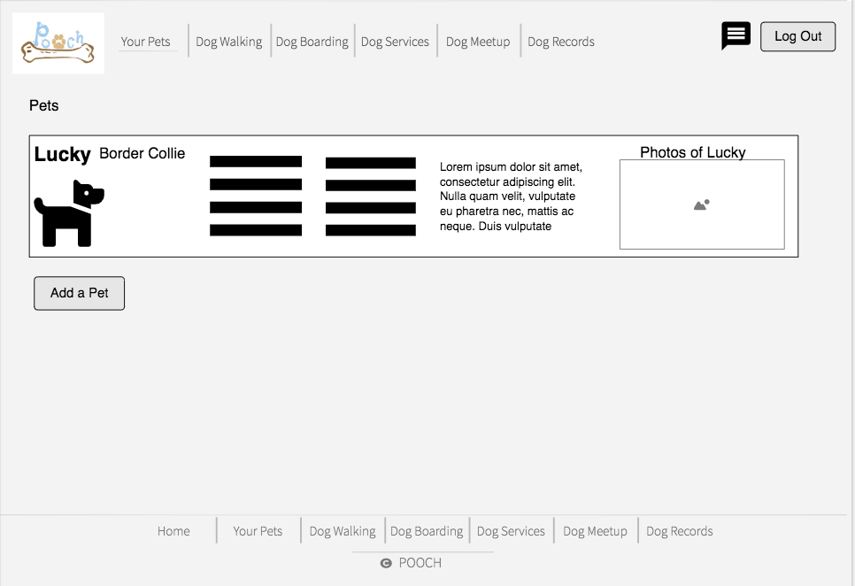

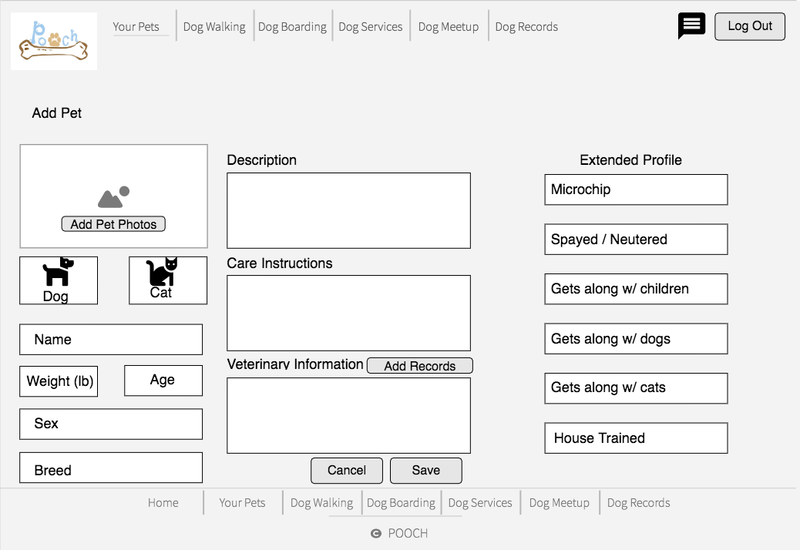

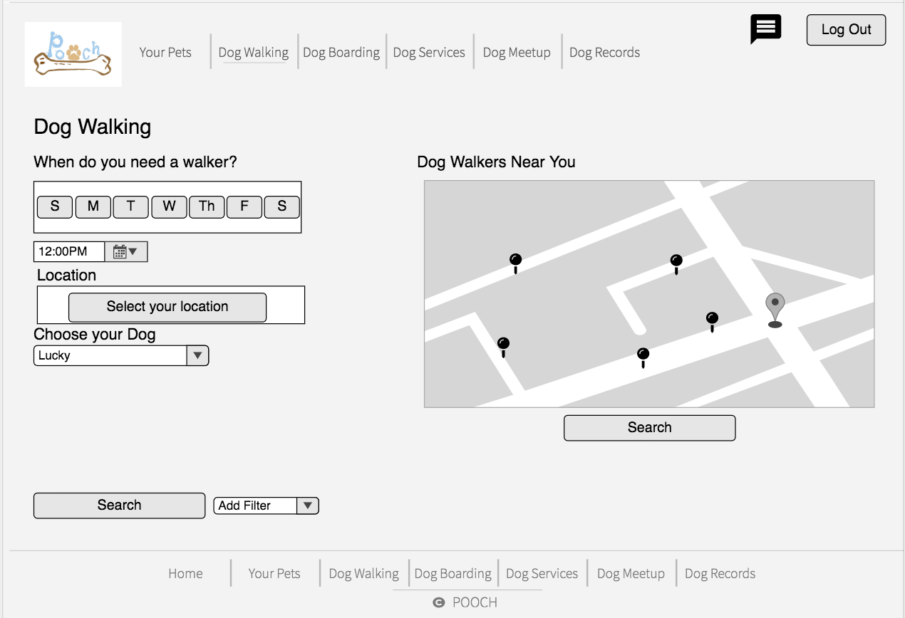

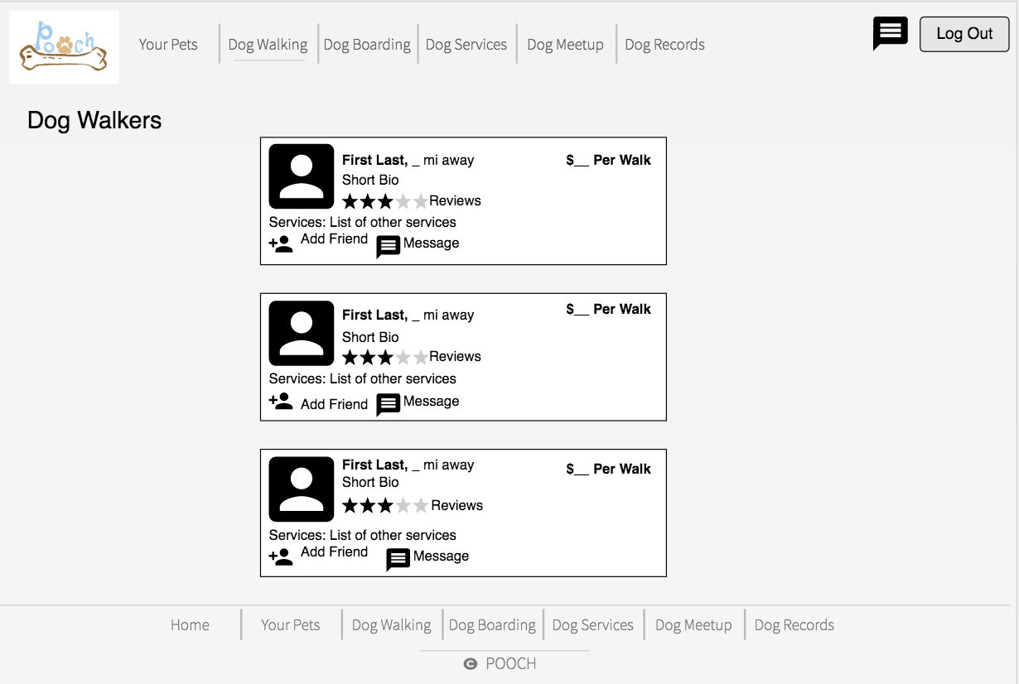

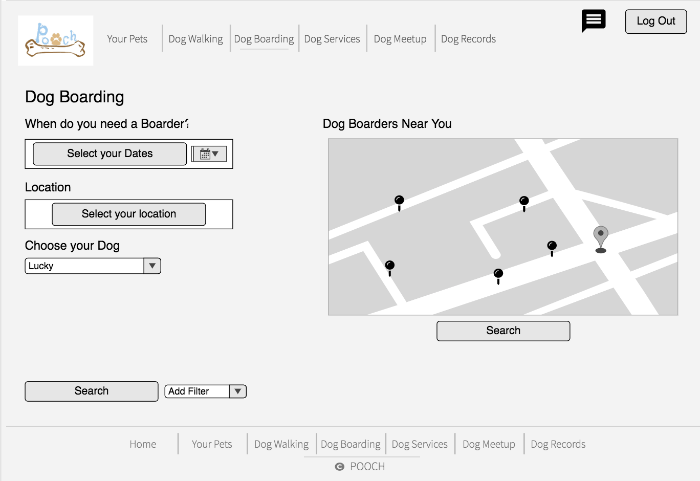

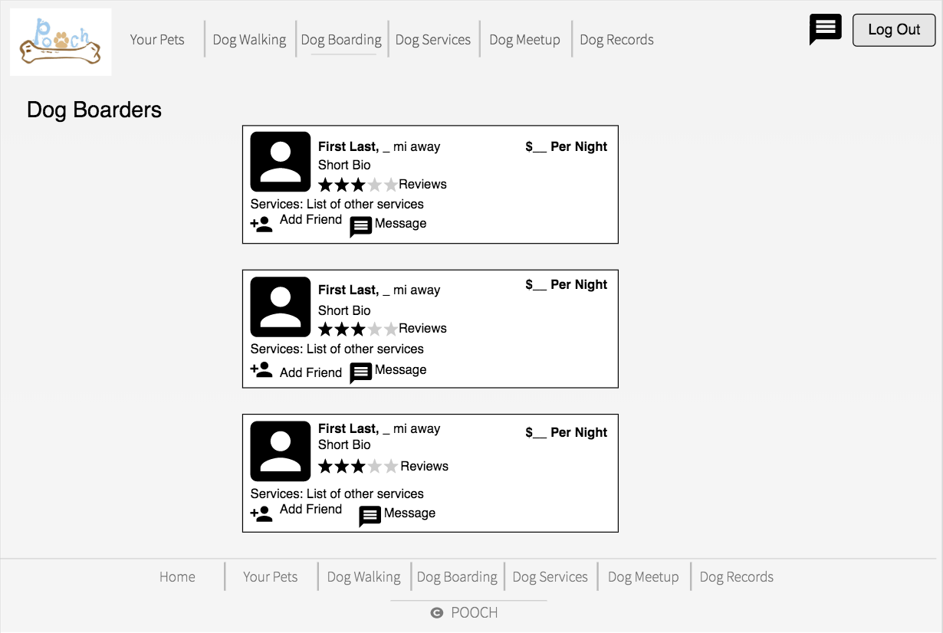

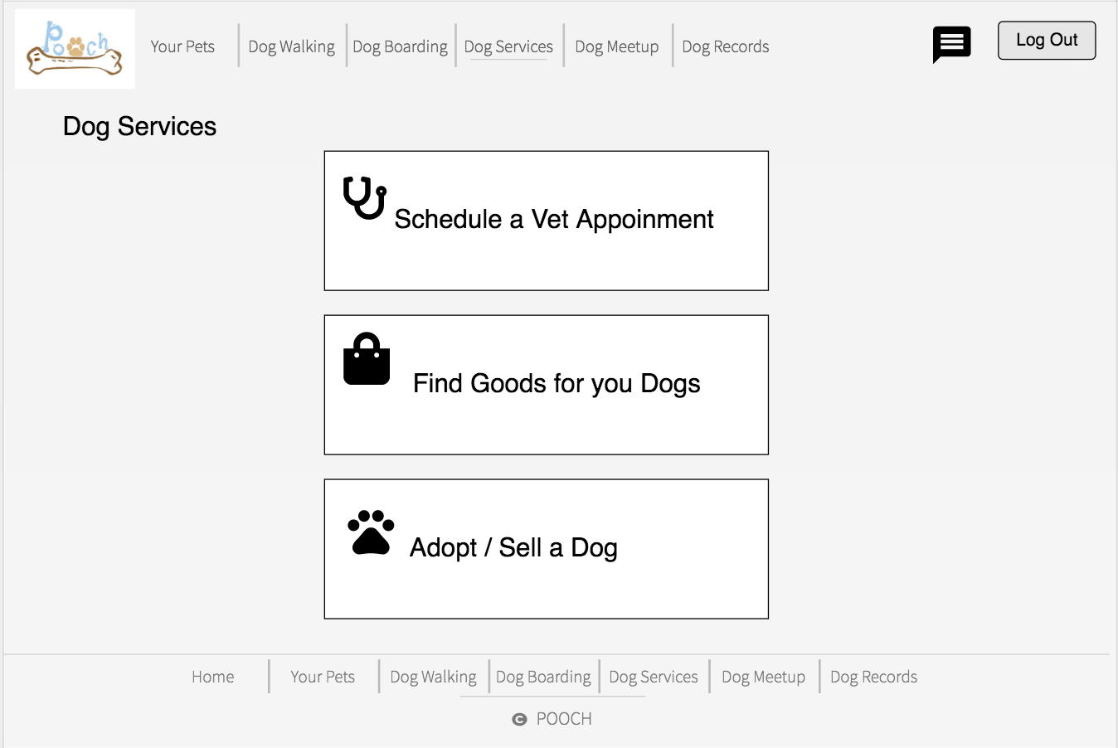

1. **Interfaces**

* **User Interface (UI)** Design emphasis on anticipating what users might need to do and ensuring that the interface elements or features that are easy to access, understand, and utilize. UI connect concepts from visual design, interaction design, and information architecture.
* **Admin Interface**, often referred to as the “back end,” that is responsible for storing and manipulating data. Once logged in, authors can use the admin interface to set up and develop a project, manage its structure and content, install extensions, and perform other tasks.
* **External API** stands for application programming interface, is a way to programmatically interact with a separate software component or resources. We are using Google API for Sign In page.

1. **Additional Functional Requirements**
   * **User registration (sign in functionality) of the application**  
     Given any user who wants to register for our web application (in other words, wants to make a profile on our application). The user must provide their email, password or sign up using the Google API. After filling out these fields, the user can choose to create a profile and thus complete the registration process.
   * **User login for the application**  
     Assuming the user has already signed up for our application, he/she can use the remember password feature to re-login using the data stored in our database. Every time a user tries to login manually, a query is run to the database and if the query returns true, then the user is logged in. otherwise, the user gets to type the password again or reset the password.
   * **Use the navigation bar to see through the features**

Users can select and go to any of the features/ services provided on the navigation bar. Navigation bar makes it easy to access all the features and it also gives the user an overview of what the software/ application has to offer them.

1. **Non-functional Requirements**

* **Portability:**   
  The software needs to be portable. It needs to be able to move from OS to OS without any problems.
* **Integrity:**

Privacy of information, such as name, email etc should be kept private.

* **Availability:**  
  Unless the system is non‐operational, the system shall present a user with a notification informing them that the system is unavailable.
* **Usability:**  
  The new product shall be easy to use by adult members (age 18 to 80) of the public.
* **Reliability:**  
  The software needs to be reliable and reliability depends upon how accurate the features of the applications work.
* **Maintainability:**

The system will not be down for maintenance more than once in a 24-hour period.

1. **Performance Requirements**
   * The product is based on the web and has to run from a web server.
   * The product shall take initial load time and depending on the internet connection and depending on the number of users active on the software.
   * The major performance depend upon the hardware and the system the application is working on.
   * The performance may also vary depending on how long it takes to return a query from the full database.
   * The data entered through the application should be more secure and even the connection to the database should be secure.
2. **Future Iterations**
   * The mobile application version of the web application, which is not just mobile friendly, but can also be downloaded from the app store on the devices.
   * An extra add on could also be the enable GPS service from the device, which helps to locate your device’s location, instead of the user manually writing his location (city or zip code).
   * Tracking system which allows you to keep track of your dog’s location.
   * Log and monitor use choices to better improve Machine Learning outputs.